A Study and Analysis of High-Order Euler Equation Solver LAGHOS

### Jonathan Lijewski, Nikodem Gazda

## Background

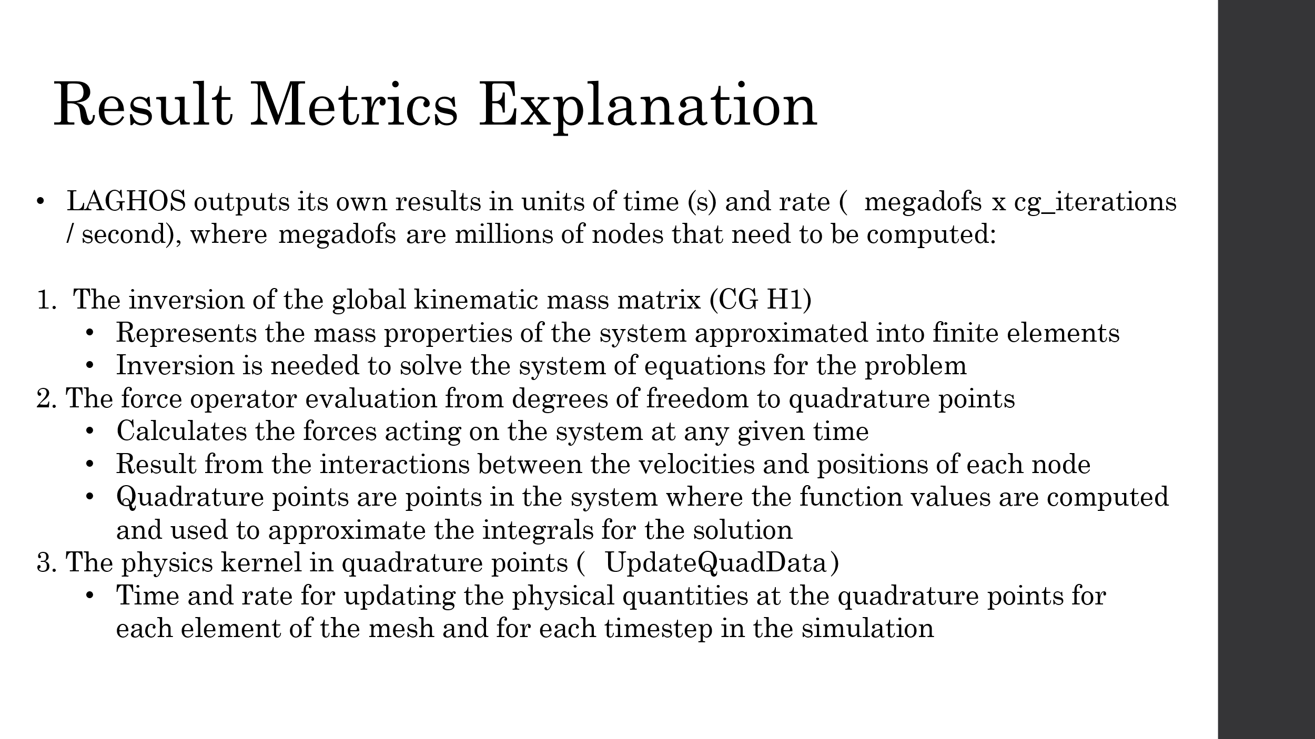

LAGHOS is a miniapp that is part of a larger software suite, CEED ( Center for Efficient Exascale Discretizations) .LAGHOS in particular is used to describe high order Euler equations of gas dynamics in a Lagrangian frame into a discrete format. Given a system of high order differential equations, LAGHOS will construct matrices for the velocity, energy, and force of the system and solve them to create a mesh of the resulting discrete system.

The global kinematic mass matrix represents the mass properties of the entire system, which is approximated into finite elements. Each of these elements has its own local mass matrix and these all add up to the global mass matrix. The inversion of this matrix is needed to solve the system of equations for the problem. LAGHOS reports the results in total time taken for this inversion and in rate (megadofs x cg_iterations / second), where megadofs are millions of degrees of freedom, or nodes that needs to be computed, and cg_iterations are each iteration of the CG method, with each iteration improving the accuracy.

The force operator is a function that calculates the forces acting on the system at any given time that result from the interactions between the velocities and positions of each node (degree of freedom). Quadrature points are specific points in each element of the approximated system where the function values are computed. The function values are used then to numerically approximate the integrals that make up the solution. This result also is reported in time and rate.

The physics kernel in quadrature points (UpdateQuadData) shows the time and rate for updating the physical quantities at the quadrature points for each element of the mesh and for each timestep in the simulation.

## Results

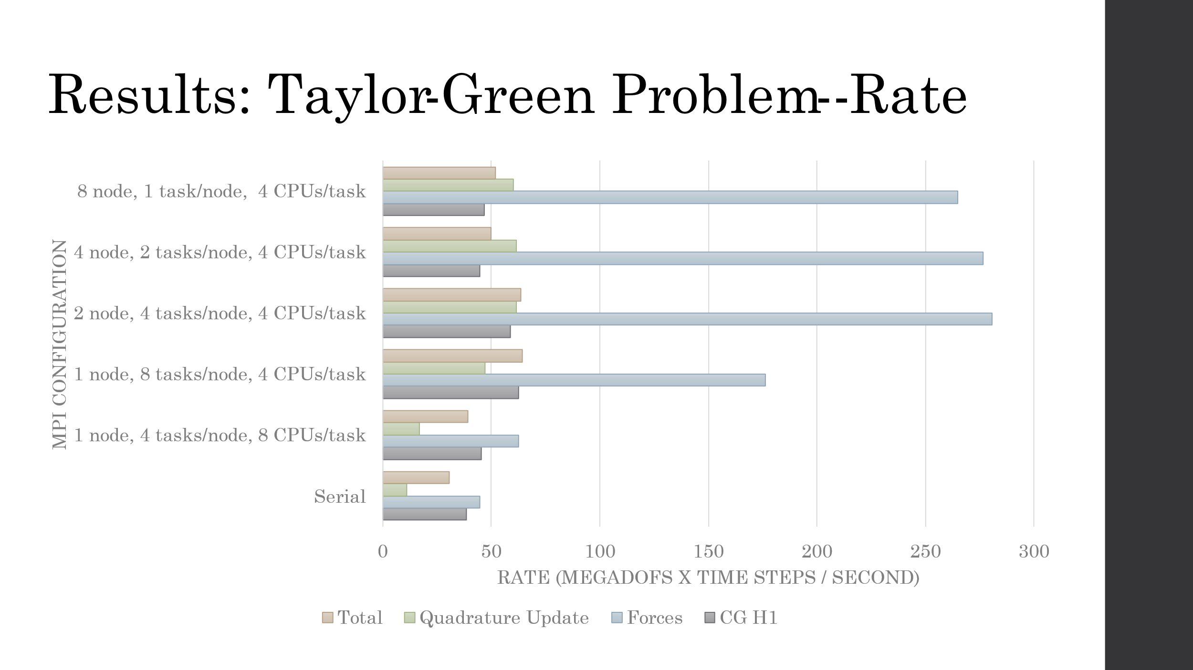

These are our results with MPI only code for the Taylor-Green problem. The configuration that received the best overall performance was with 1 node, 8 tasks, and 4 CPUs. The configuration with 2 nodes, 2 tasks/node, 4 CPUs/task outperformed the previous configuration in results 2 (Forces operator) and 3 (Quadrature Update), however, since result 1 (CG H1) dominates the runtime and the previous configuration performed better there, the previous configuration still performed better overall. It's possible the data required to stream hit a bottleneck when using just 1 node, and the larger bandwidth of 2 nodes may have improved the Forces and Quad Update results so.

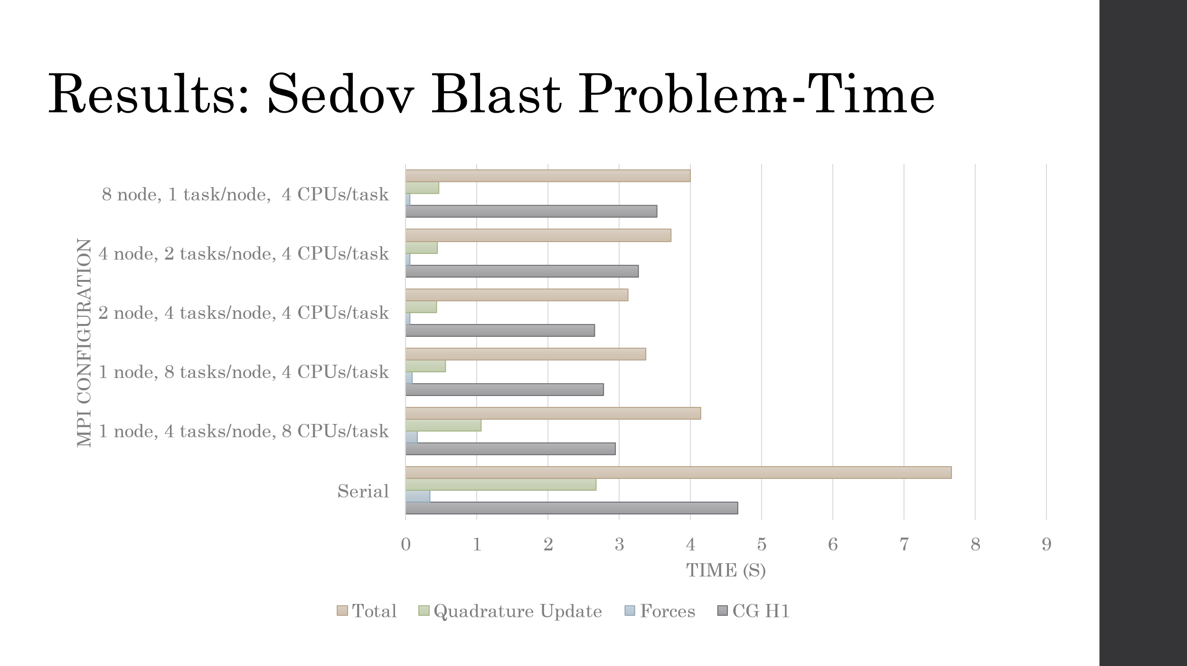

These are the MPI only results for the Sedov Blast problem. The MPI configuration with 2 nodes and 2 tasks/node performed best in these runs, though the configuration with 1 node and 8 tasks followed closely behind. The 2 node configuration still drastically outperformed the 1 node in the Forces and Quad Update results, granting the previous theory about bandwidth a little more authority. Additionally, the results for Forces and Quad Update worsen slightly with the addition of more nodes, which likely means that these other configurations also benefit from the gain in bandwidth but suffer from some additional overhead in coordinating the extra nodes.

## Literature Review for Paper 1

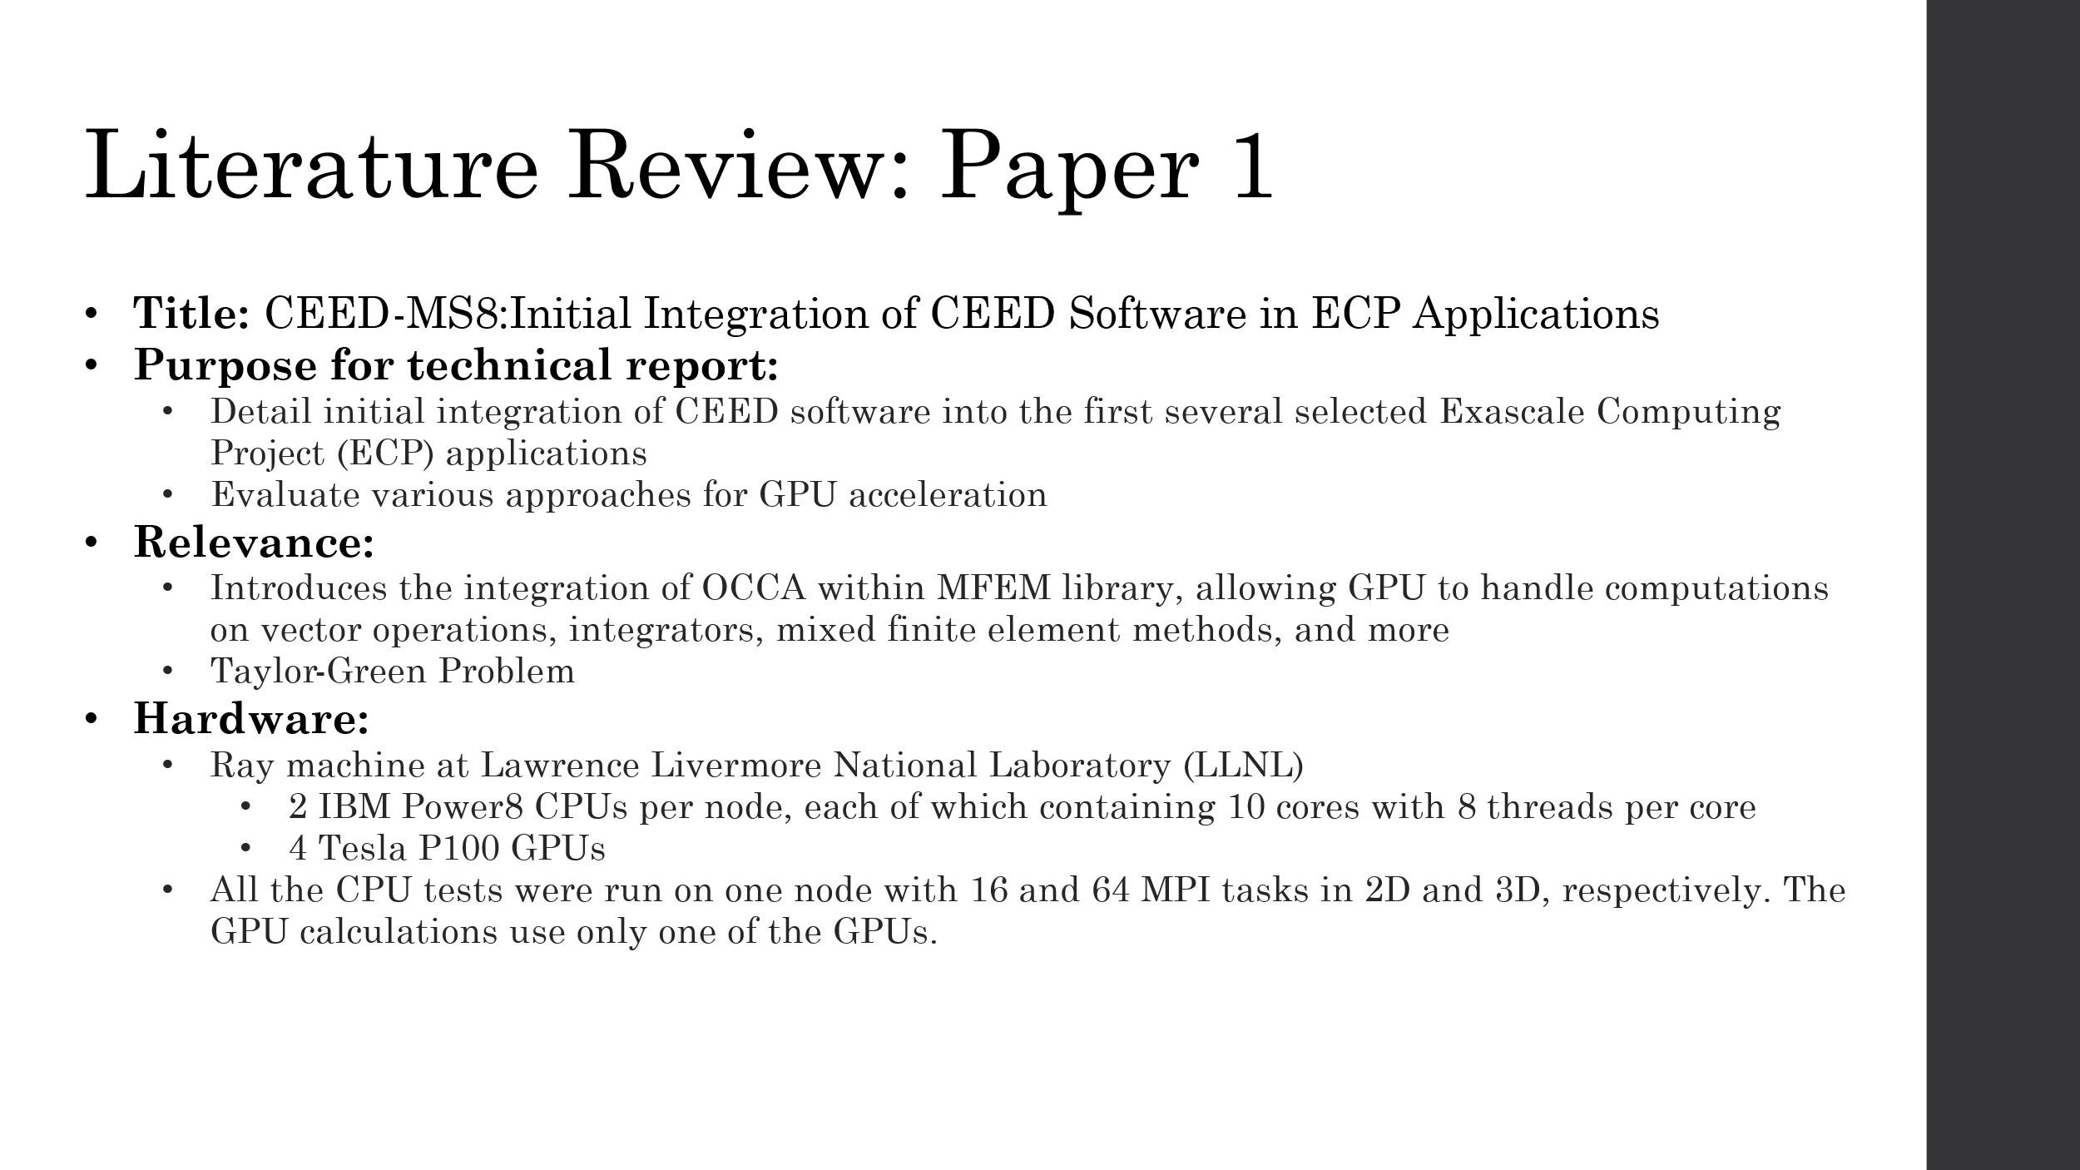

This technical report was written by the U.S. Department of Energy to report on the initial integration of CEED software into the first several selected Exascale Computing Project (ECP) applications, as well as to evaluate various approaches for GPU acceleration, including LAGHOS (a more specific generalization of the technical report can be found on page VI of the report).

The part of the report that focuses on LAGHOS introduces a new feature that allows for a GPU port in LAGHOS and MFEM (One of the libraries LAGHOS relies on) developed based on the Open Concurrent Compute Abstraction (OCCA). The integration of OCCA within the MFEM library allows the GPU to handle computations on vector operations, integrators, mixed finite element methods, and more [1]. For the results, the researchers used the GPU-enabled mass integrator for CG H1 and custom kernels for the force operator evaluation and update in quadrature points (Result options 1, 2, and 3 as discussed before).

The tests seen below were computed with the Ray machine at LLNL, with two IBM Power8 CPUs per node, each of which containing 10 cores with 8 threads per core, and 4 Tesla P100 GPUs. All the CPU tests were run on one node with 16 and 64 MPI tasks in 2D and 3D, respectively. The GPU calculations use only one of the GPUs.

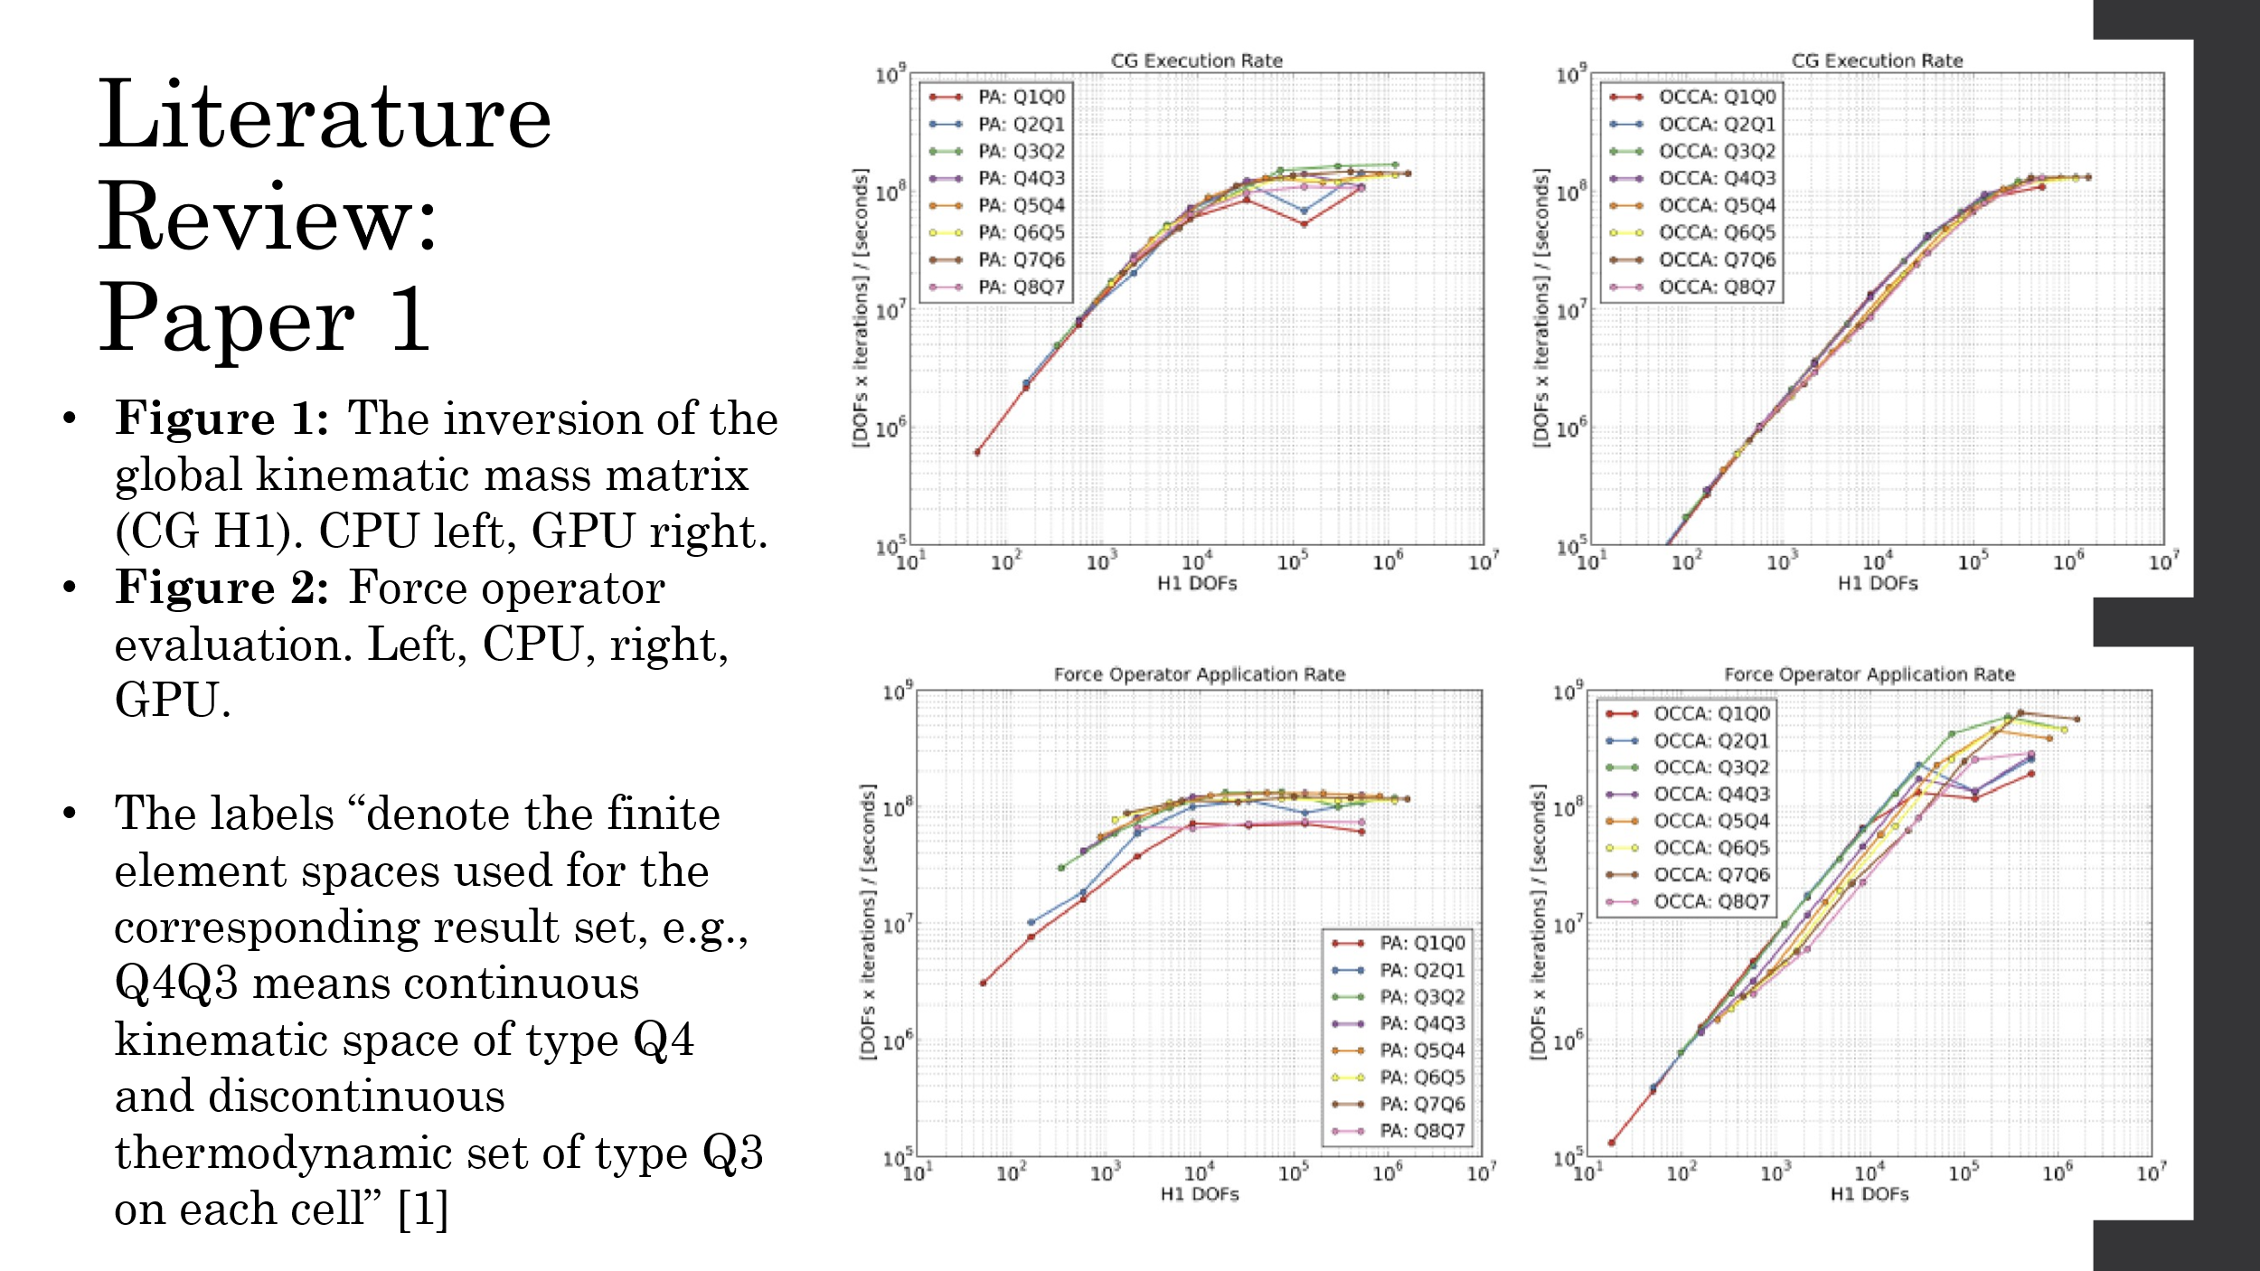

Fig. 1 shows that the GPU version computes slower than the CPU partial assembly but, though the researchers state they believe that this performance can be improved significantly. For the CPU, the rate ranges between ~0.5-100 megadofs*iterations/second and for the GPU, the rate ranges between below 0.1 to around 100 megadofs*iterations/second.

Fig. 2 shows the GPU outperforming the CPU in the force operator evaluation with about an order of magnitude improvement, going from 16 CPU cores to 1 GPU. For the CPU, the rate ranges between ~1.2-100 megadofs*iterations/second while the GPU ranges between around 0.1 to around 800 megadofs*iterations/second.x

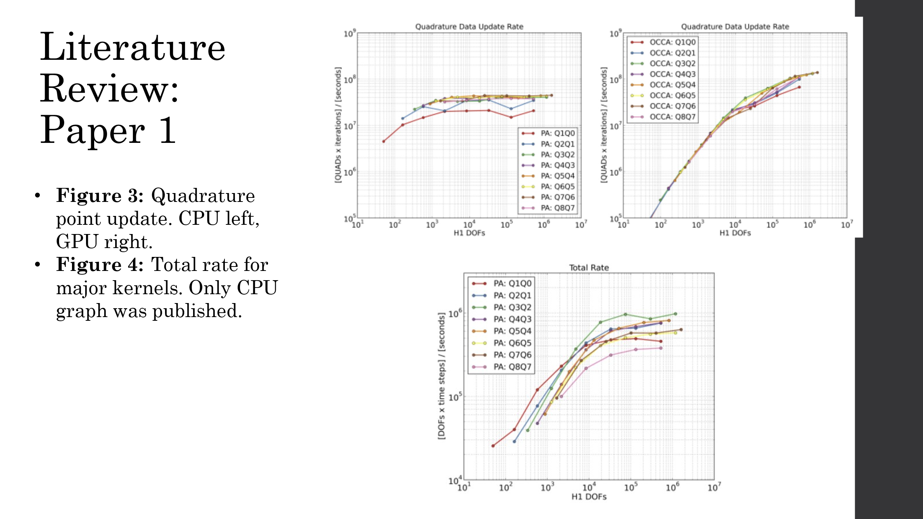

Fig. 3 shows the GPU outperforming the CPU in the quadrature point update with higher test size, but the CPU outperforming the GPU when testing with a smaller test size. Overall, the CPU seems more consistent when tested against a range of test sizes. The researchers claim the GPU exhibits betters performance in this figure by exploiting the fact that these calculations do not involve any communication.

Fig. 4 shows the overall performance/average of the 3 major kernels run. It’s not clear how they obtained this result because the performance seems to be 2 orders of magnitude worse than the previous plots, maxing out at a rate of ~100k.

## Results compared to Paper 1

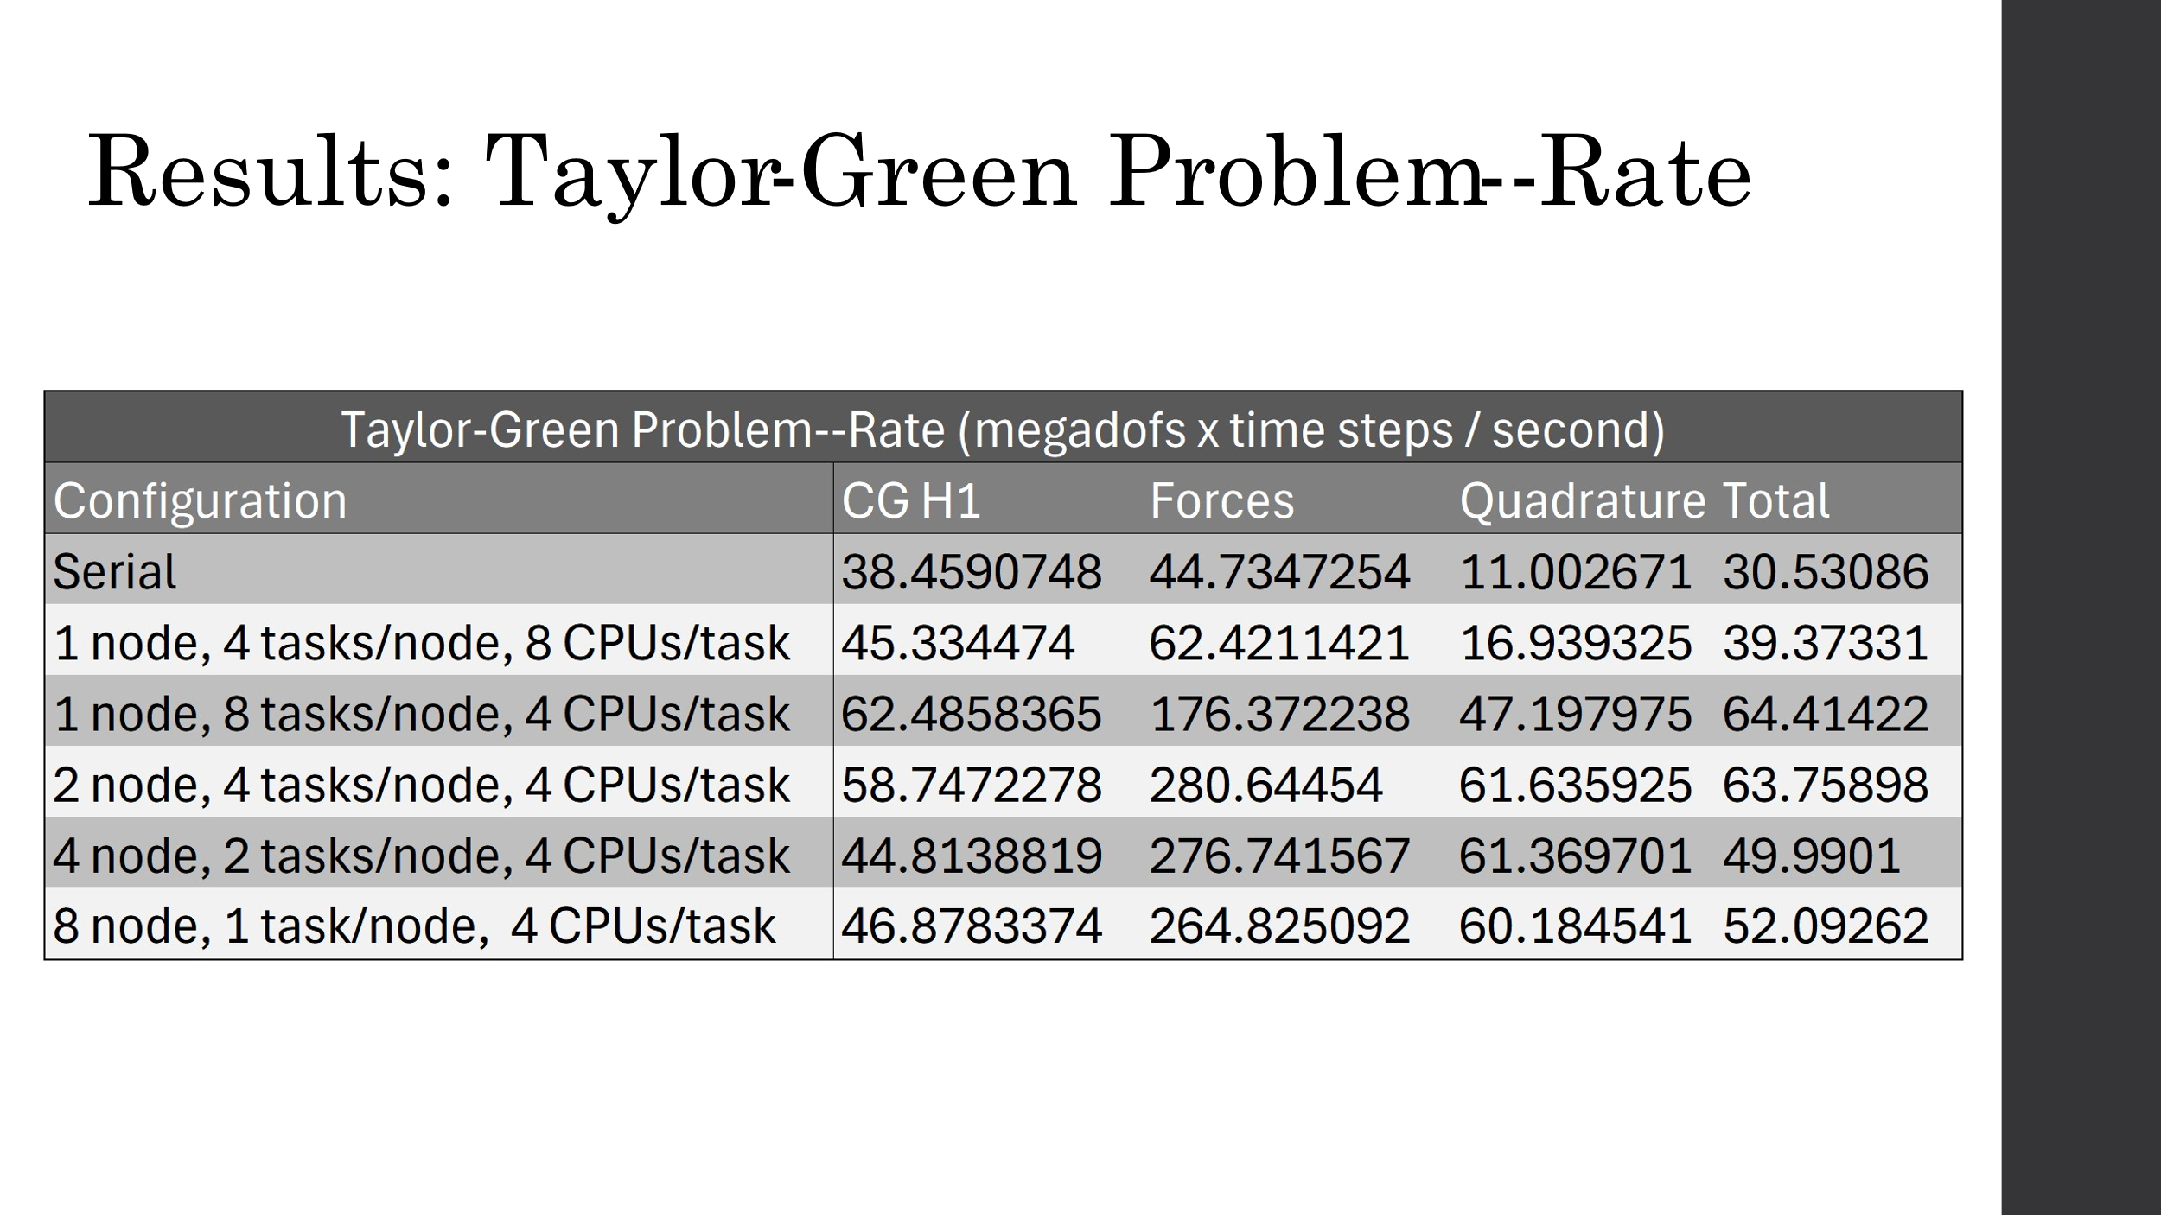

These are our results running the same problem. The problem size was 500k, so between 10e5 and 10e6 on the x-axis in the plots above. Compared to Fig. 1 from the paper, which saw a rate of ~100M at our problem size for both CPU and GPU, HiPerGator performed about half as well with the best MPI configuration using 1 node with 4 tasks and 8 CPUs per task. Compared to Fig. 2, HiPerGator outperformed the paper’s CPU results by about 3x with a rate of ~300k (using 2 nodes and 2 tasks/node), compared to the paper’s ~100M. The paper’s GPU results, however, outperformed HiPerGator by ~2.5x at a rate of ~800M. Compared to Fig. 3., HiPerGator saw similar results to the paper’s CPU run while the GPU’s performance about doubled HiPerGator’s. Fig. 4 from the paper only displays the CPU’s results, and HiPerGator outperformed the paper by about 50x with a rate of ~60M compared to the paper’s maximum rate of ~1M.

## Literature Review for Paper 2

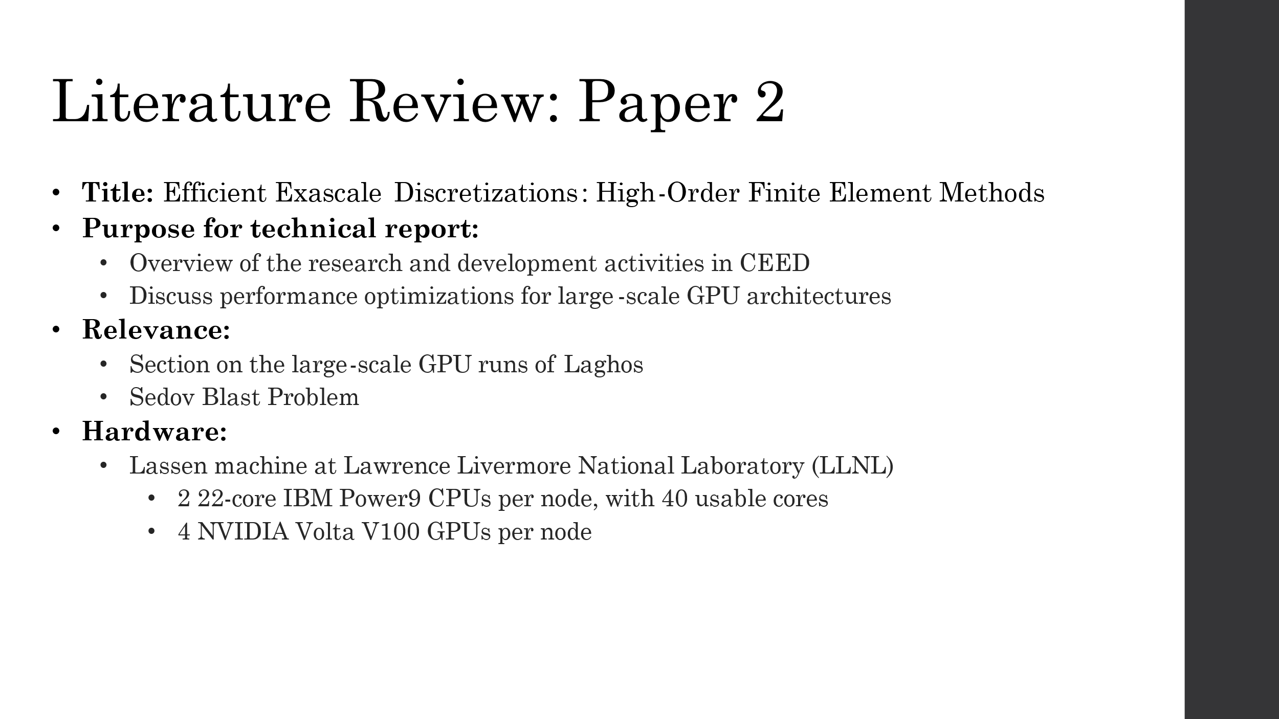

Similarly to the previous paper, this paper provides an overview of the research and development activities in CEED [2]. In this overview, the researchers discuss miniapps (including LAGHOS) as well as their work on performance optimizations for large-scale GPU architectures. Our interest for this paper was in the section on the large-scale GPU runs of Laghos, performed on Lawrence Livermore National Laboratory’s (LLNL) Lassen. Lassen is an HPC system with >34,000 cores, where each node has two 22-core IBM POWER9 processors, with 40 usable cores and four NVIDIA Volta V100 GPUs per node [3].

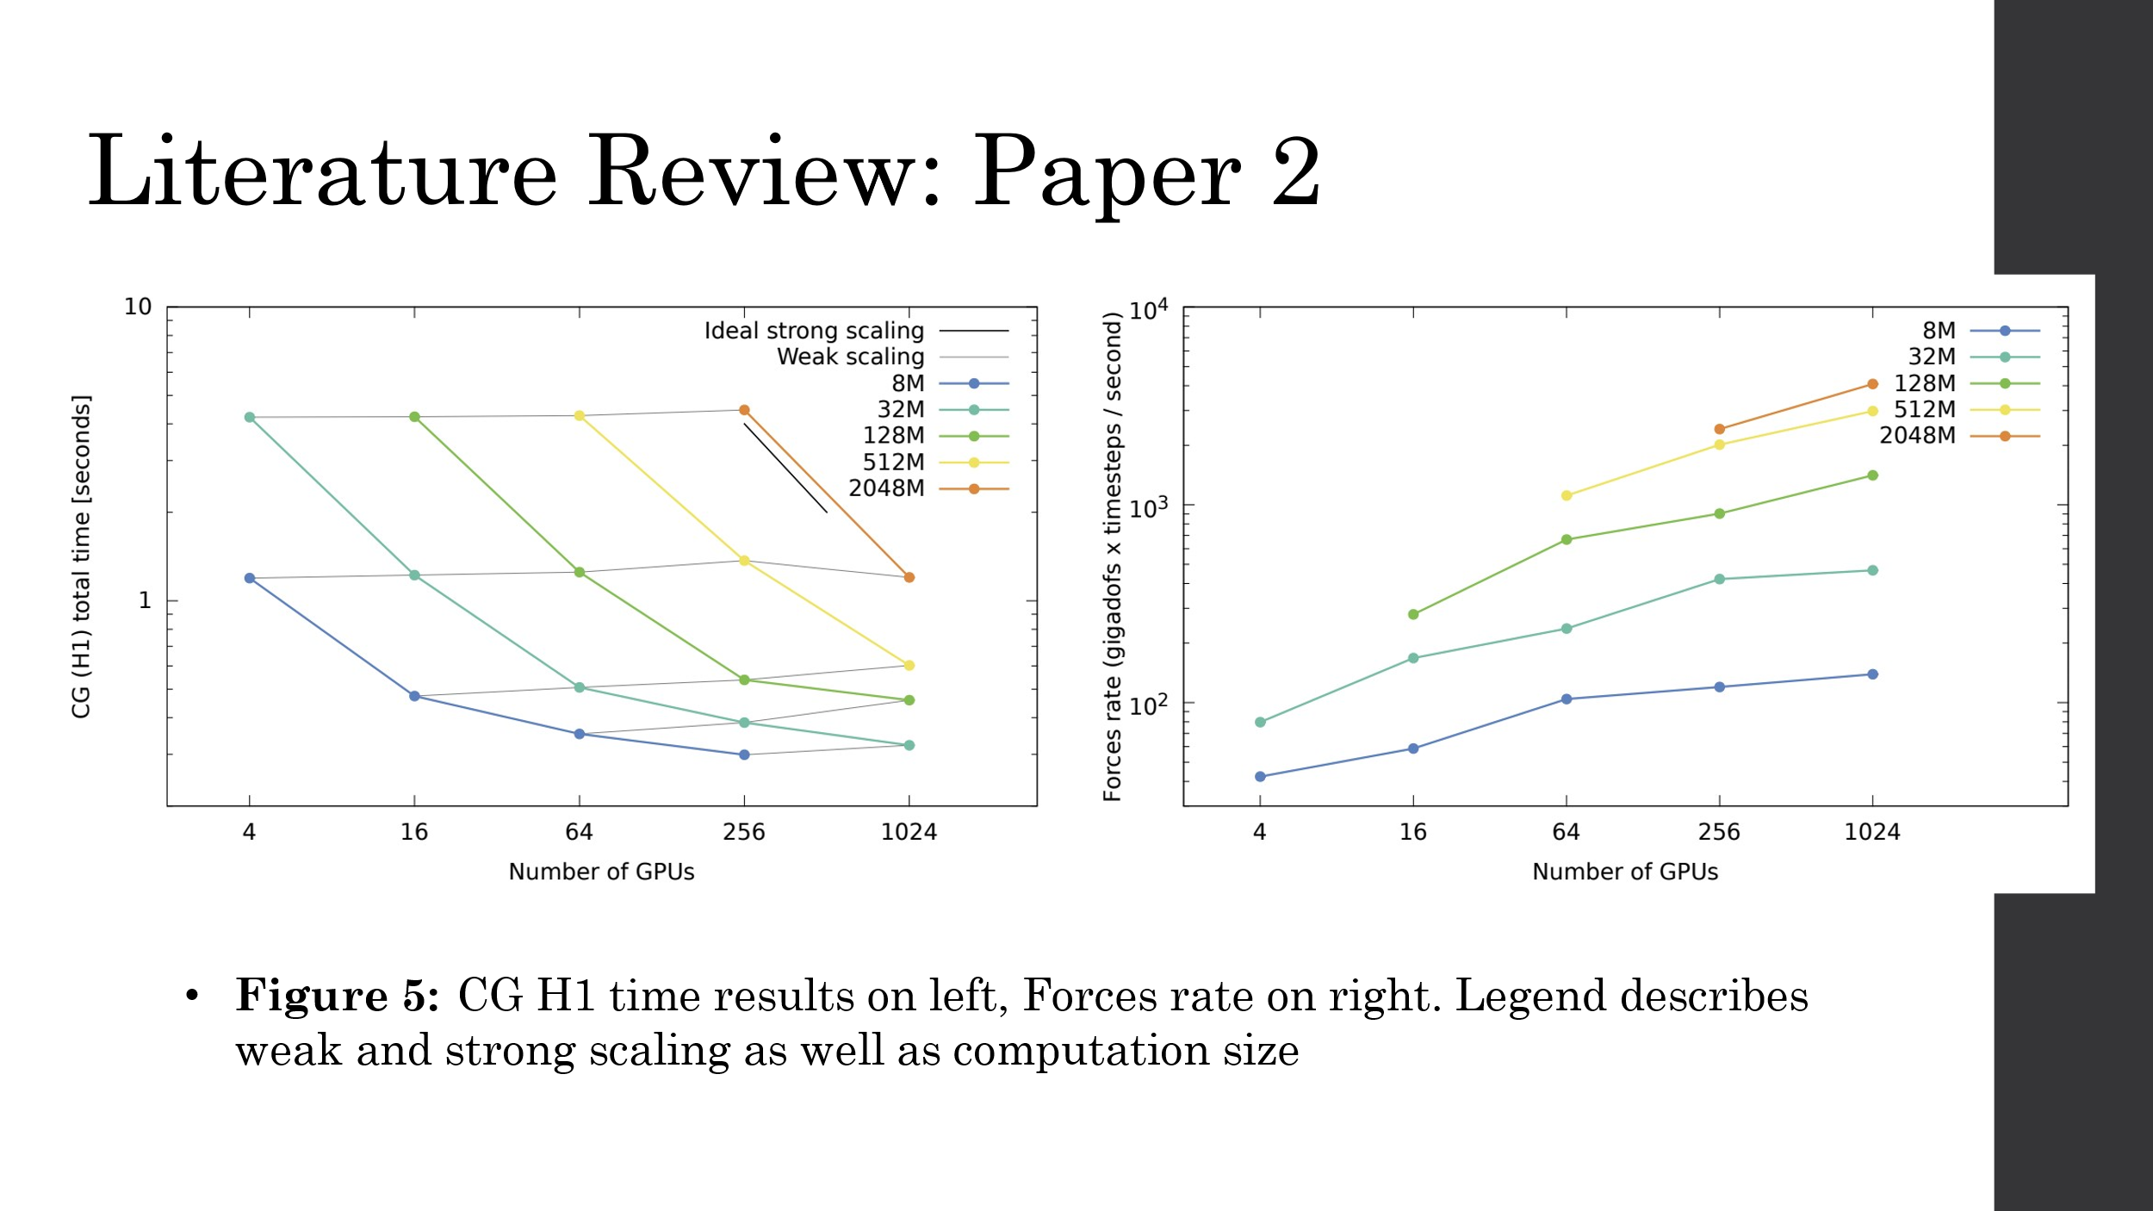

Results are presented in Fig. 5, showing both the weak and strong scaling (gray lines and colored lines, respectively) obtained on between 4-1024 GPUs on problem sets of increasing size. The experiments test for both the CG total time and Forces rate. These graphs show that ideal strong scaling is possible for large enough problem sizes while weak scaling is more easily reached through all the range of the runs.

## Results compared to Paper 2

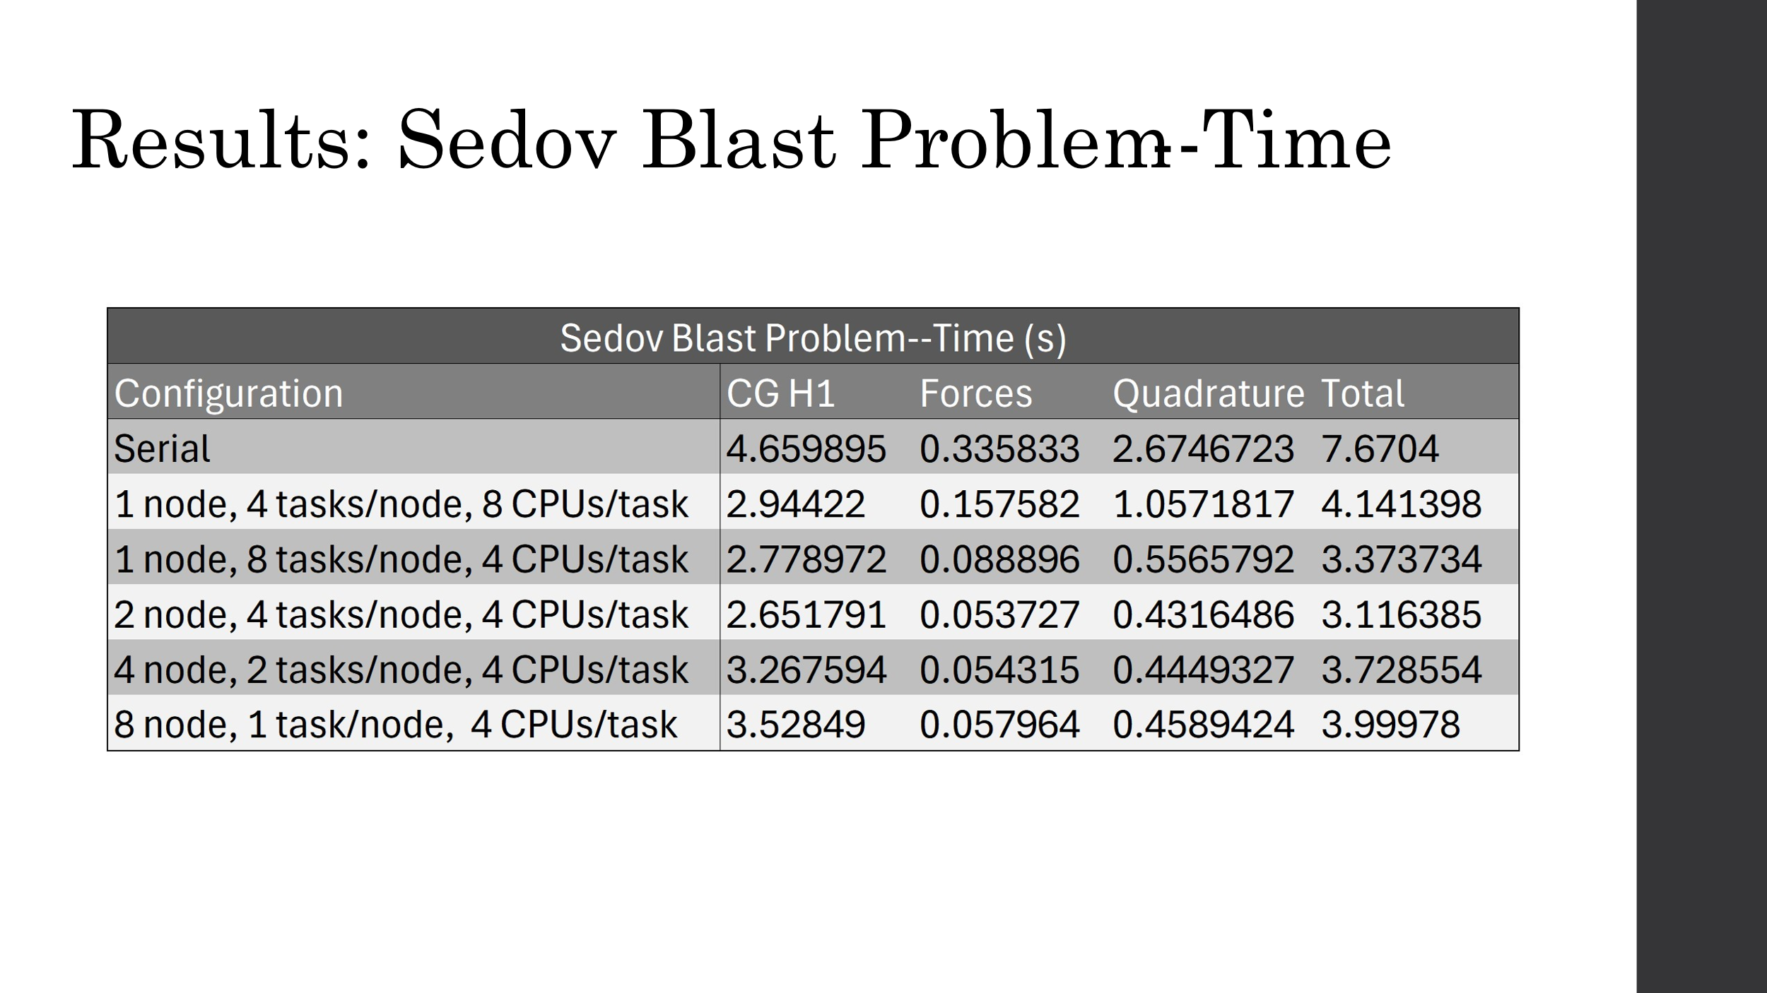

While it’s difficult to compare our results to this paper’s because we’re using CPUs here and the paper is using multiple GPUs, the HPC the paper uses outperforms HiPerGator in most cases, though our results outperform the paper’s in certain configurations. HiPerGator’s best performance for CG H1 is ~2.6s. The left plot in Fig. 5 also measures CG H1 runtime and the area between the yellow and green lines represent our problem size of ~200M. Looking up from 64 GPUs, you can see the paper’s runs on a problem size of 128M takes ~1s while runs on a problem size of 512M takes ~4s, meaning HiPerGator is performing at the approximate capacity of 64 GPUs on the Lassen system. In other words, HiPerGator outperforms Lassen when Lassen uses 16 or less GPUs, and Lassen outperforms HiPerGator when using 256 or more GPUs.

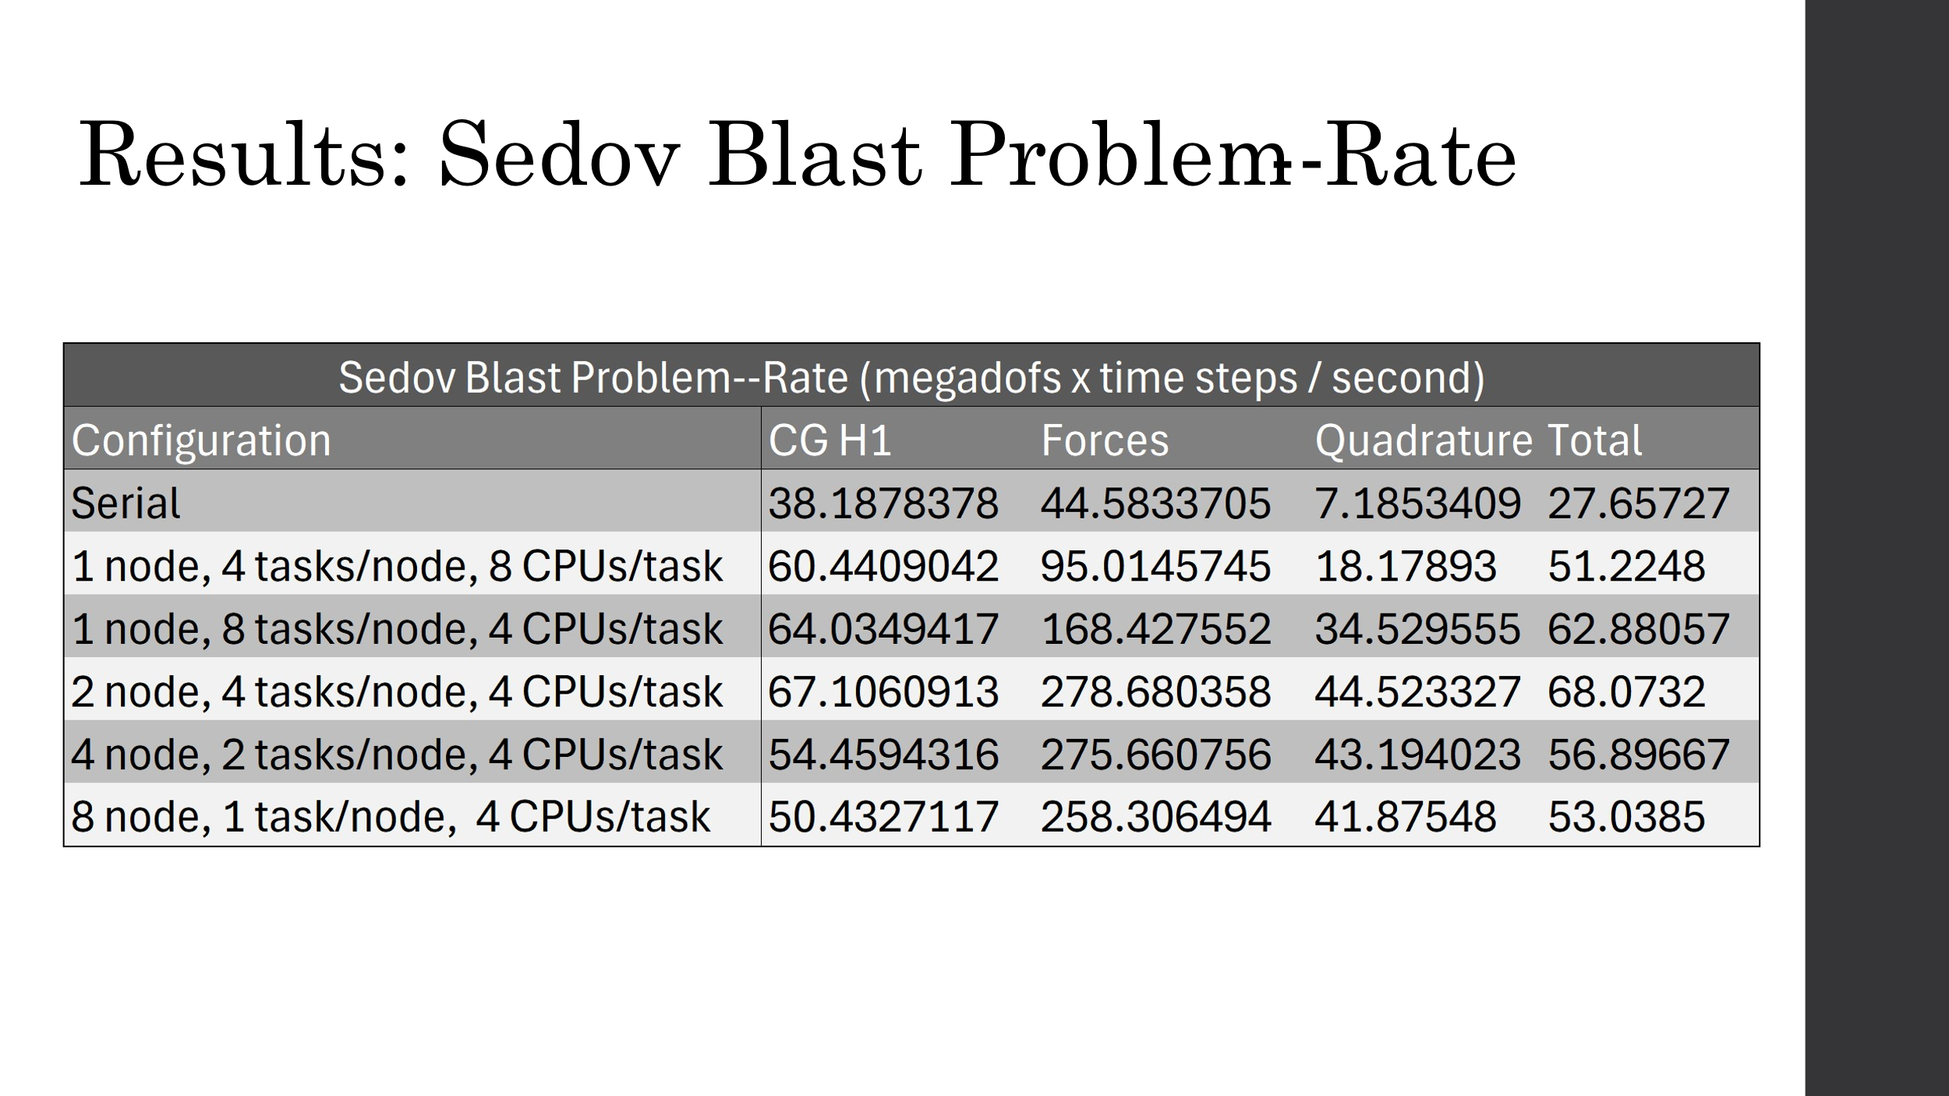

On the right side of Fig. 5, we see the rates for the Forces result. The y-axis is in units of gigadofs*iterations/second. The results we got for the Forces result are all under 1 gigadof*iteration/second, meaning each configuration outperformed HiPerGator. This is to be expected—the Forces result always computes at a rate ~4x the other results and this figure shows the rate increasing with increased problem sizes, meaning it’s most likely an embarrassingly parallel task, where GPUs are expected to outperform CPUs.

### MPI, MPI+OpenMP, and CUDA

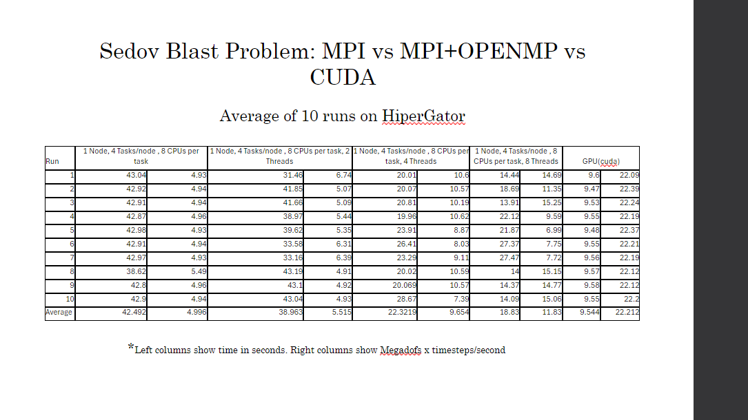

In comparisons between the different configurations of Laghos, performance increases can be seen with the more parallelizable backends enabled. For the above results, the Sedov Blast problem was explored on Laghos with the times and rates for the MPI, MPI+OpenMP, and CUDA versions running. There was a significant offset in the times found, with the best performing MPI configurations averaging around 45 seconds. This was believed to occur due to the overhead of the OpenMP backend. Even if it is not enabled for the MPI runs, the MFEM library was still compiled with OpenMP code for the future runs. Regardless, a clear performance increases is seen moving to more parallelized configurations, with the CUDA configuration performing the best.

## Profiling

### Gprof

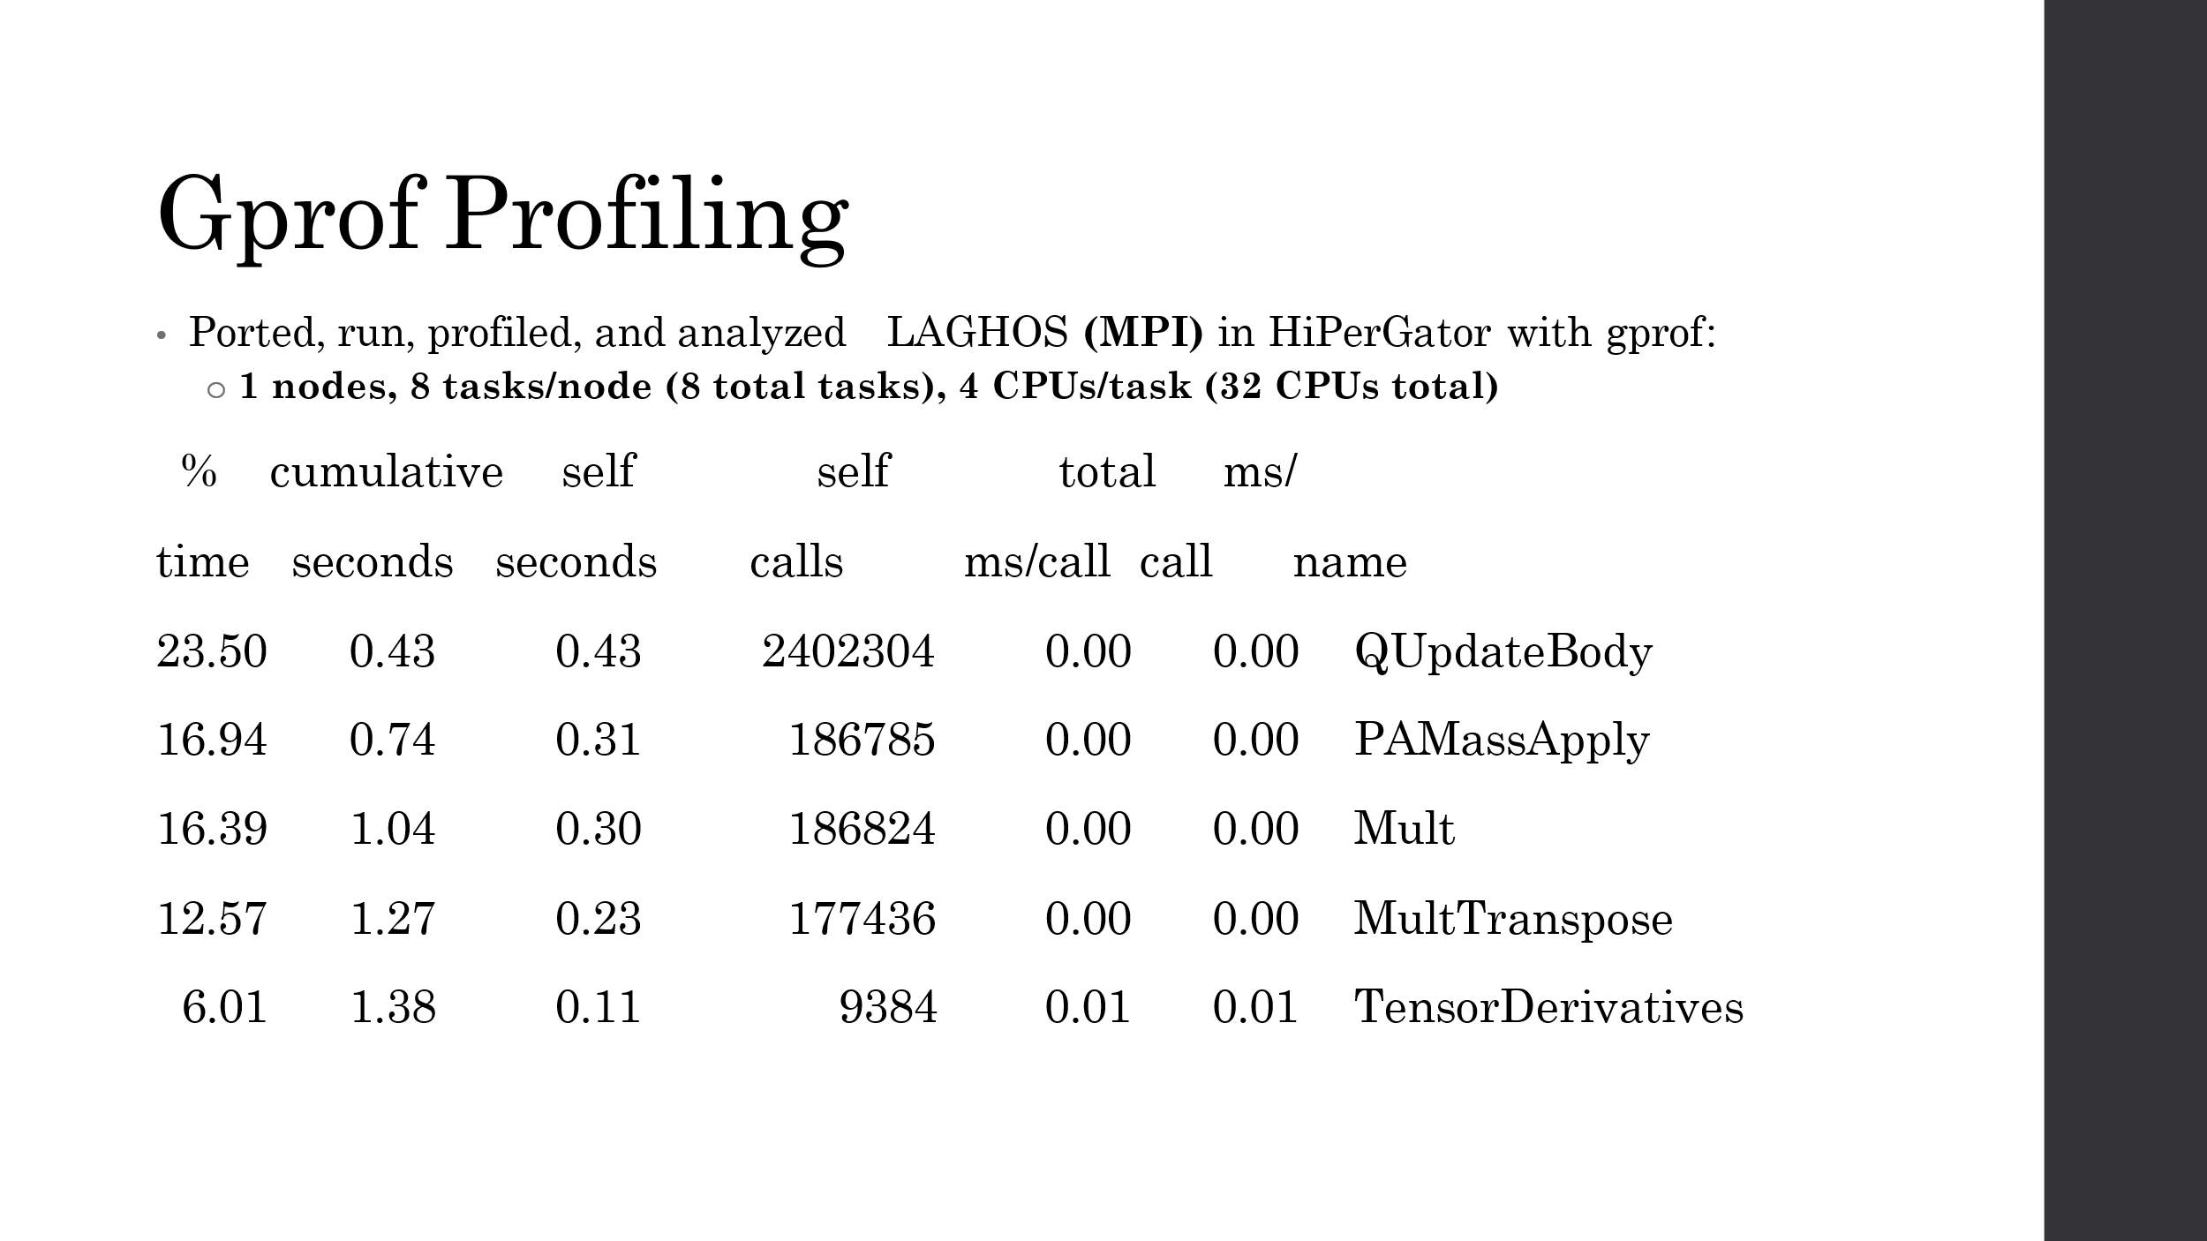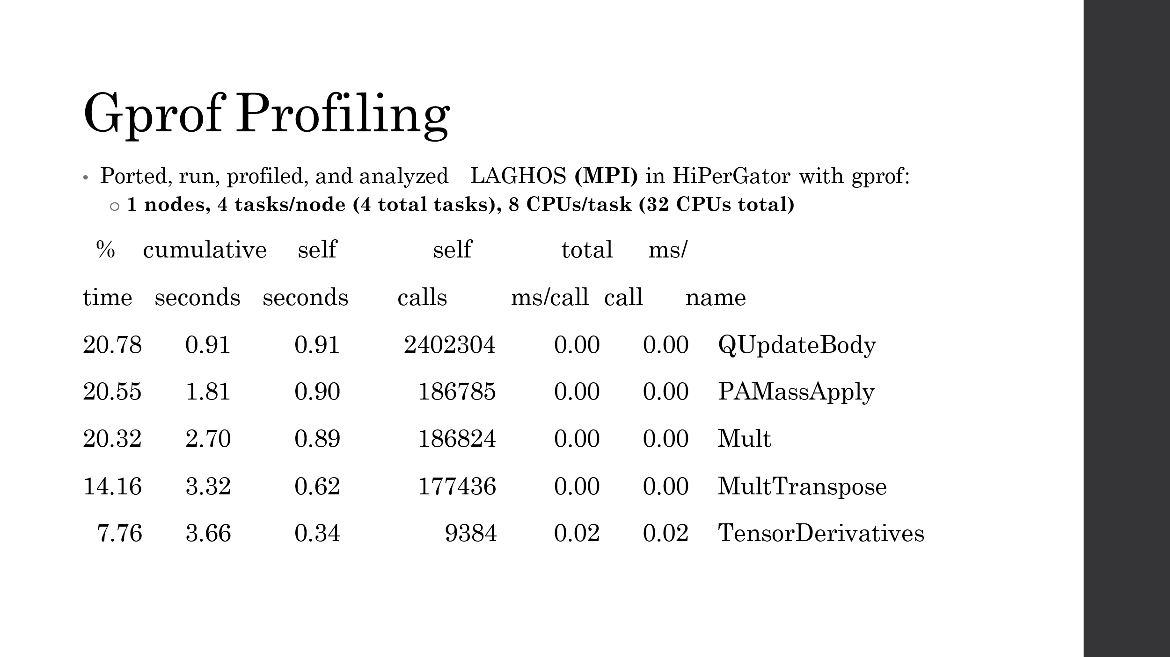

The gprof profiling results show us that the MFEM functions dominate the runtime for LAGHOS. QUpdateBody corresponds to the quadrature update and PAMassApply and Mult correspond to the CG H1 and Forces operation results. You can also see that as the MPI configurations change, the numbr of self calls stays the same. This is because each rank uses the same number of CPUs for each of these configurations.

### Nvprof

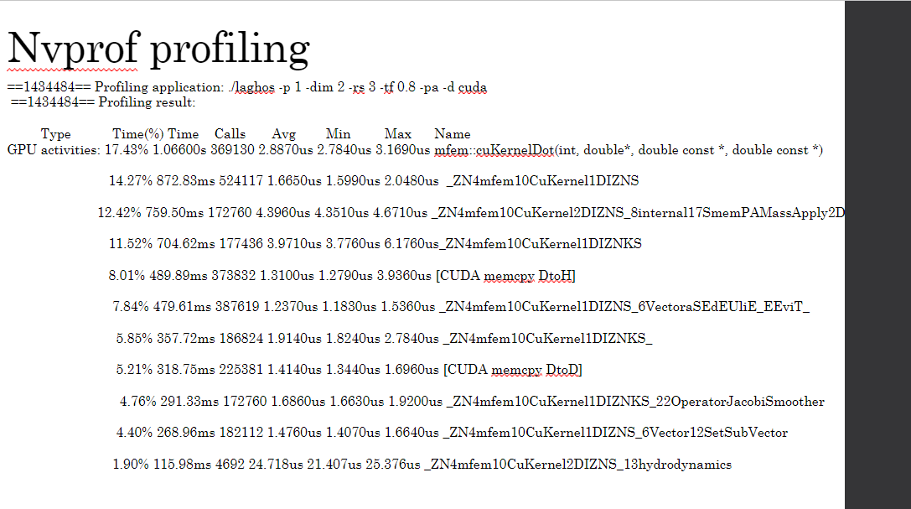

In addition to Gprof profiling, Nvprof profiling was used to take a closer look at the CUDA backend of Laghos. This configuration was run on HiperGator using GPU resources to complete the Sedov Blast problem. The results show several CUDA kernels that were built in the MFEM library to mimic the parallel MPI/OpenMP functions already in MFEM. A significant amount of time was also spent in memory allocation functions (memcpy/malloc).

### Vtune

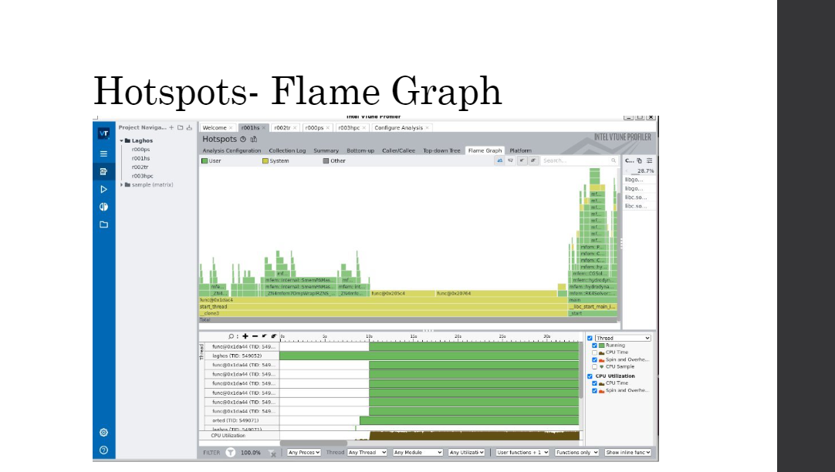 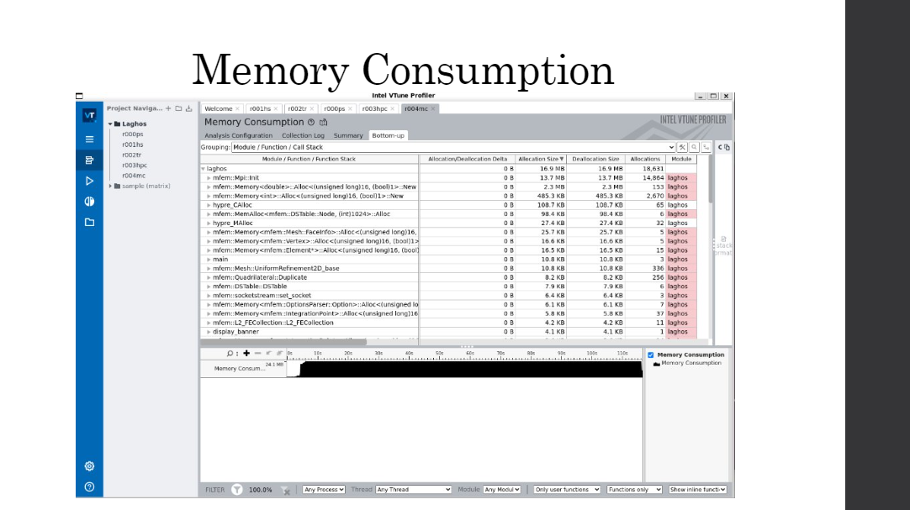

The final profiler that was used was Vtune, an intel-based profiler, focused on highlighting memory costs and call traces of threaded applications. Laghos was run on the same Sedov Blast problem off of HiperGator, on a local intel machine. The OpenMP backend as enabled and the problem ran with 15 threads. The performance was similar to the Gprof results. The same MFEM library functions were found to be the HotSpots of the program. The Flame Graph results show most of the function calls happening at the end of the run time. Each thread was running for most of the run time, except for the master thread, which was constantly running. The Memory Consumption shows a similar story, with the library functions that had the most calls taking up most of the memory allocated to the program. The memory allocation functions in MFEM also ended up using a significant amount of time and space. There were also a number of vector computation functions that were listed in the HotSpots trace callback but not the Gprof profiler. These functions were the main focus for testing alterations to the OpenMP code.

## Changed code

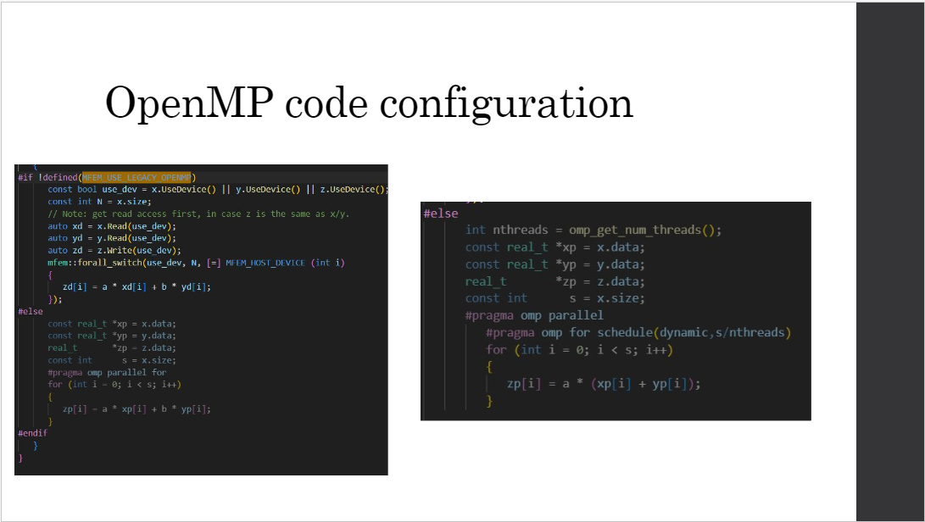

Around 10 instances of OpenMP code being used to directly add vector components were found in the MFEM library. All instances used a standard omp parallel loop and default scheduling (static). These portions of code were changed to dynamic scheduling and the chunk size was altered to reflect various constant values to compare to the default (N/numThreads).

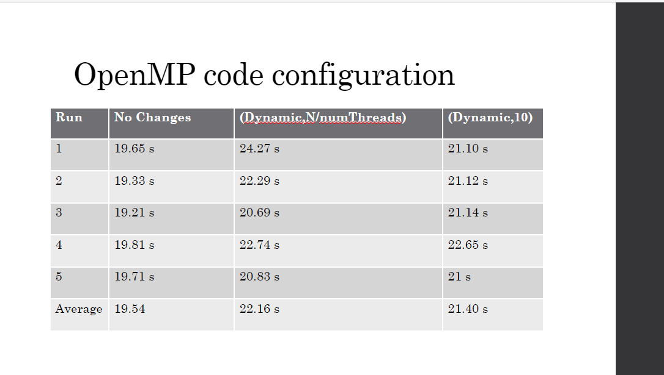

The results show a slight decrease in performance when running the dynamically scheduled version of the code. There is not a large enough increase in time to indicate a substantial difference, but some of the results could be linked to the overhead of the program or the overall regular format of the data before runtime.

## References

## https://github.com/CEED/Laghos

## Initial Integration of CEED Software in ECP Applications

## [2109.04996] Efficient Exascale Discretizations: High-Order Finite Element Methods (arxiv.org)

## https://ceed.exascaleproject.org/software/

## https://mfem.org/